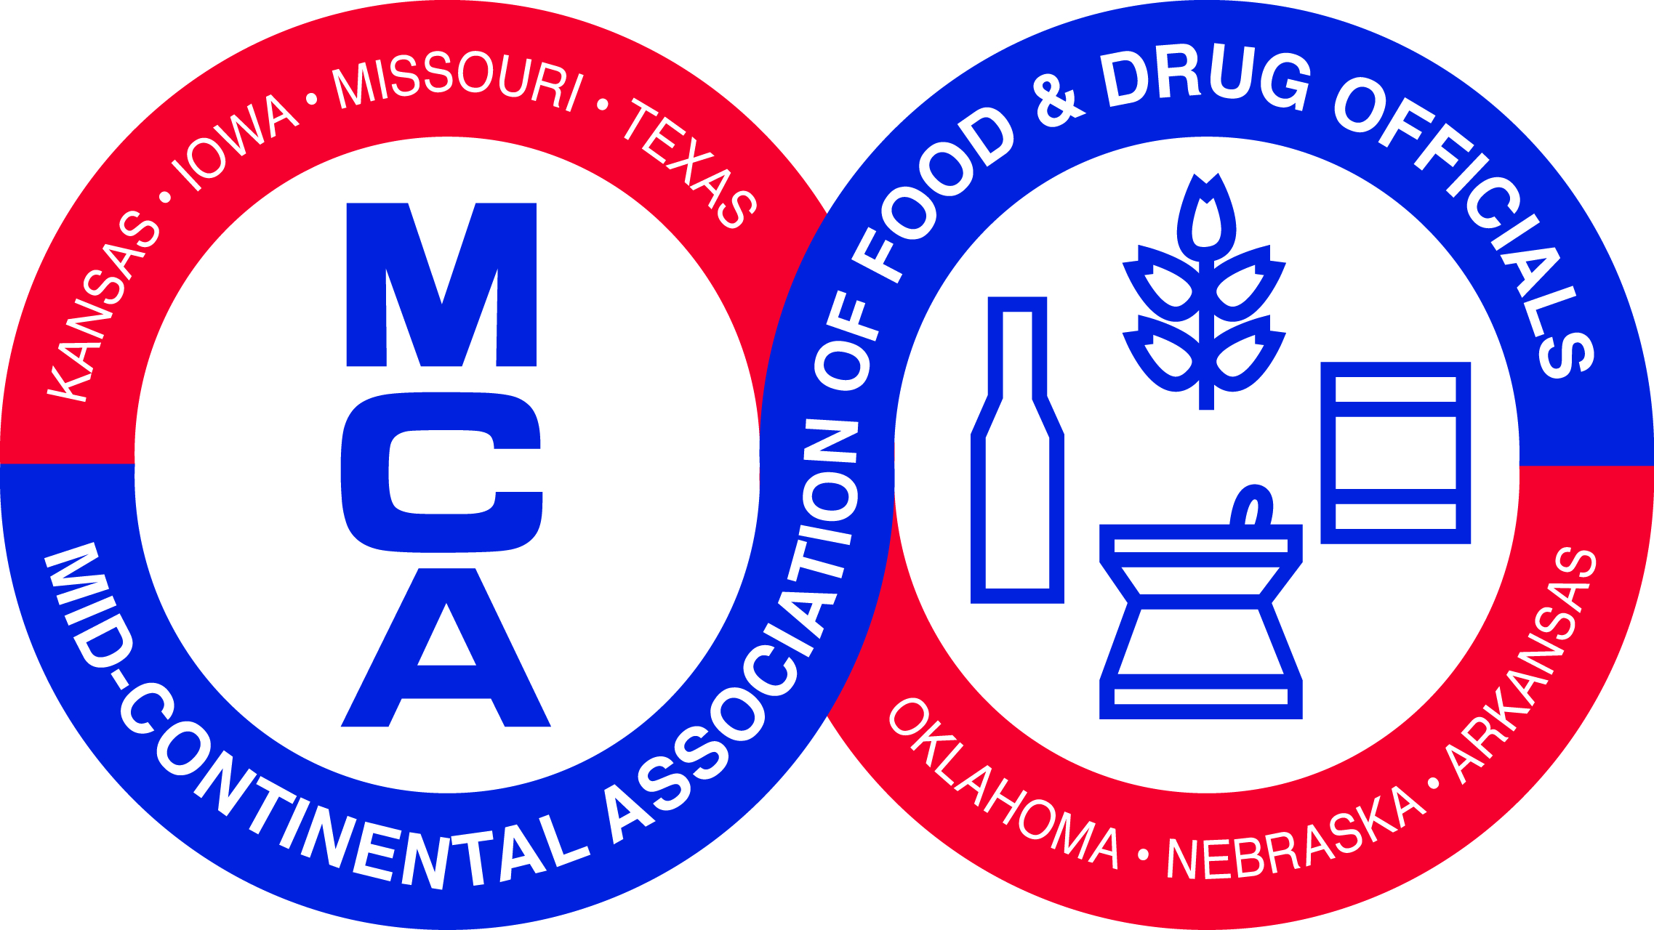
Tuesday, February 23, 2016
Moderator: Angela Kohls, FDA,
Office of Partnerships

7:00 am | Registration
8:00 am | Welcome | Representative of Missouri
8:15 am | History of Food and Drug Law | Joe Corby, Executive Director, Association of Food and Drug Officials
Listeria Monocytongenes at Retail
9:00 am | Listeria Monocytongenes at Retail Best Practices | Joel Willnerd, Supervisory Investigator, USDA, FSIS
9:45 am | Best Practices for Regulatory Agencies Performing Retail Surveillance Sampling for Listeria Monocytongenes | Alida Sorenson, RRT Coordinator, Minnesota Department of Agriculture
10:15 am | Break
10:30 am | Industry Panel on Controlling Listeria Monocytongenes at Retail | Melinda Hayman, Ph.D. Director of Microbiology, Grocery Manufacturers Association  Cherie Alderson, Food Safety Supervisor, Schnuck Markets
11:30 am | Studies on Lm at Retail | Susan Hammons, Ph.D. candidate with Department of Food Safety, Purdue University
12:15 pm | Lunch
Foodborne Illness Investigation and Control
1:30 pm | Controlling Norovirus and Food Establishments and Firms | Dr. Kristen Gibson, Assistant Professor, Molecular Food Safety and Microbiology, University of Arkansas
2:15 pm | Controlling Norovirus: The Branson Experience | Samantha Green, Epidemiologist, Taney County Health Department
2:45 pm | Break
3:00 pm | Partner Sharing
3:15 pm | Using Social Media to Detect Potential Foodborne Outbreaks | Leila Thampy, Epidemiologist, St. Louis City Health Department
4:00 pm | Engaging Local Health Department in Illness Investigation with Rapid Response Teams | Missouri, Texas, and Iowa RRTs
4:45 pm | IFPTI Fellow Presentation: Awareness of Food Safety Risks in Production of Produce on Oklahoma Farms | Bryan Buchwald, Section Director, Oklahoma Department of Agriculture, Food & Forestry
5:00 pm | MCAFDO Executive Board Meeting
5:30 pm | Adjourn

Wednesday, February 24, 2016
Moderator: Tressa Madden, FDA,
Office of Partnerships

Retail Food Protection – Steve Mandernach confirming speakers
8:00 am | Retail Program Standards Grants: What have we accomplished and learned? | Cindy Kunkel, FDA, Regional Retail Food Specialist – moderator  Possible Presenters:  Harris County, TX  City of Columbia MO  Lincoln/Lancaster, NE  States of Iowa, Indiana, Kansas, Minnesota, and Texas
9:00 am | MCAFDO Business Meeting | All meeting attendees participate
9:30 am | Lessons Learned Standards | Tressa Madden, FDA, Office of Partnerships  Angela Kohls, FDA, Office of Partnerships
10:00 am | Break
10:15 am | Industry Point of View: Grading, Scoring, and Posting of Inspections | Mick Miklos, National Restaurant Association
11:00 am | National Coordination Center and National Curriculum Standard | Dave Read, International Food Protection Training Institute  Jerry Wojtala, International Food Protection Training Institute
11:45 am | IFPTI Fellow Presentation: Barriers to Inspections of Ethnic, Women-Operated Food Establishments in  Dallas, Marshall, and Polk Counties, Iowa | Thao Nguyen, Food Safety Specialist, Iowa Department of Inspections and Appeals
12:00 pm | Lunch
Food Safety Modernization Act – Steve Moris confirming speakers
1:00 pm | AFDO Update | Stan Stromberg, AFDO President  Director, Food Safety Division, Oklahoma Department of Agriculture, Food , and Forestry
1:30 pm | Implementation of FSMA at the State Level | Adam Inman, Assistant Program Manager, KS Dept. of Agriculture – moderator  Overview of Factors for consideration of states: state discussion with 2 MCAFDO and 2 NCAFDO program representatives
2:15 pm | Industry Panel: Challenges of Implementing FSMA | “very small manufacturer” - TBD  South Dakota Soybean Processors (tentative)  Conagra Foods (tentative)
3:15 pm | Break
3:30 pm | Partner Sharing
3:45 pm | Collaboration on Enforcement | FDA Dallas/KC/States KS, IA, TX? Miguel, Kansas Steve, Scott Platt
4:45 pm | Closing Remarks | Ellen Dettman, President MCAFDO
5:00 pm | Adjourn

MCAFDO 2017
Nebraska – dates and location TBD

The program has been approved for ___ NEHA Continuing Education contact hours.

USAFoodSafety User Group Meeting will be held on Thursday, February 25, 2015.

