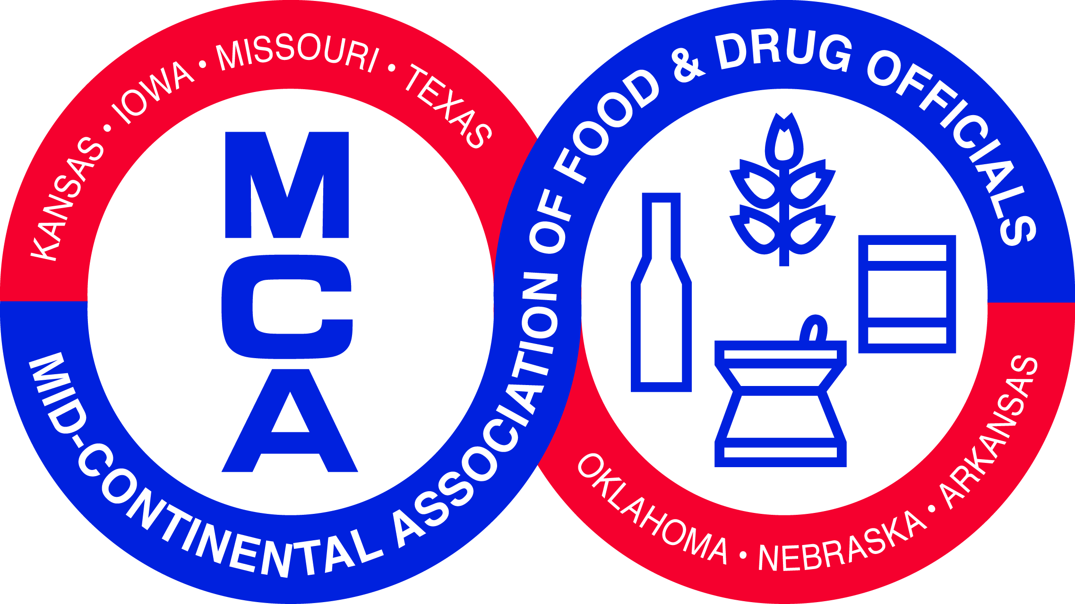
Tuesday, February 24, 2015
Moderator: Angela Kohls, FDA,
Office of Partnerships

7:00 am | Registration
8:00 am | Welcome | Jim Reese, Secretary and Commissioner of Agriculture, Oklahoma Department of Agriculture  Karen Kreuzer, Acting Deputy Regional Director, Southwest Region, FDA
8:15 am | Responding to Natural Disasters at Retail | Joe Corby, Executive Director, AFDO
9:00 am | FSMA Produce Safety Rule: Challenges and Moving Toward Implementation | Byron Beerbower, Compliance/Food Safety Planning and Response Manager, Michigan Department of Agriculture
9:45 am | Office Partnerships Update | Tressa Madden, Standards Implementation Staff, FDA Office of Partnerships
10:15 am | Break
10:30 am | Egg Safety & Salmonella enteritidis Control | George Zameska, Paster Training  Sponsored by National Pasteurized Eggs
11:30 am | Indian Health Service and Food Safety | Capt. Danny Walters, Environmental Health Officer, Oklahoma City Area Indian Health Services
Noon | Lunch
1:00 pm | AFDO Update | Stephen D. Stich, AFDO President  Director, Division of Food Safety and Inspection  NY State Department of Agriculture and Markets
1:30 pm | Food Safety at Farmer’s Markets | Dr. Kristen Gibson, University of Arkansas
2:15 pm | Partner Sharing
2:30 pm | Break
3:00 pm | Paddlefish processing and Roe/caviar | Jason D. Schooley, Paddlefish Biologist, ODWC Paddlefish Research Center
4:00 pm | Why are programs standards important to inspectors? What do I get out of this? | Moderator: Angela Kohls, FDA  Katherine Simon, Minnesota Department of Agriculture  Kirsten Knopff, Minnesota Department of Agriculture  Debbie Watts, Tulsa Health Department  Jennifer Young, State Liaison, FDA Dallas District Office
5:00 pm | MCAFDO Executive Board Meeting
5:30 pm | Adjourn

Wednesday, February 25, 2014
Moderator: Tressa Madden, FDA,
Office of Partnerships

8:00 am | MCAFDO Business Meeting
8:30 am | Food Banks and Emergency Response | Cari Ogden, Vice President for Community Initiatives, Regional Food Bank of Oklahoma
9:00 am | First Hand Experiences with Tornados | Troy Skow – Program Administrator with the Consumer Protection Division at the OCCHD  Waite Colbaugh- Public Health Specialist & Emergency Response Coordinator at the OCCHD  Phillip Maytubby- Director over Emergency Response Program and Public Health Division for the OCCHD
10:00 am | Break
10:15 am | Preventive Controls: Challenges Moving Forward, An Industry Perspective | Moderator: Sue Holbert, Enterprise Regulatory Affairs, ConAgra Foods  Warren Stone, Senior Director of Science, Policy, Compliance and Inspection, GMA  Lenora Howard, Sr. Regulatory Affairs Specialist, ConAgra Foods  Michele M. Evans, Executive Director of Food Safety and Quality Assurance, Diamond Pet Foods
12:15 pm | Lunch
1:15 pm | Controlling Listeria monocytogenes (Lm) in Retail Delicatessens | Tracy Hernandez, Compliance Officer, USDA FSIS
2:00 pm | Rapid Response Teams: What works and what doesn’t? | Moderator: Julie Vosilus, State Liaison, Kansas City District Office, FDA  Mark Buxton, Missouri RRT  Steven Mandernach, Iowa RRT  Catherine Thibodaux, Texas RRt
2:45 pm | Break
3:15 pm | Food Safety Audit/Global Food Safety Initiative | Jason Young, Quality Management and Global Food Safety Initiative Specialist, Oklahoma State University
4:00 pm | Essential Instructor Skills | Jerry Wojtala, Executive Director, International Food Protection Training Institute
4:45 pm | Closing Remarks | Bryan Buchwald, President MCAFDO
5:00 pm | Adjourn

MCAFDO 2016
Branson, Missouri—February 23-24, 2016

The program has been approved for 14 NEHA Continuing Education contact hours.

